SIMULATIONS

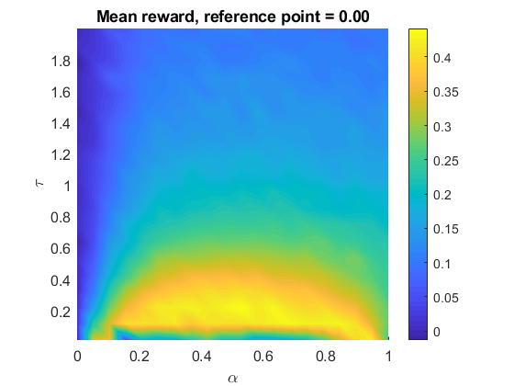

bestAlpha = 0.5263

bestTau = 0.2195